UML diagram

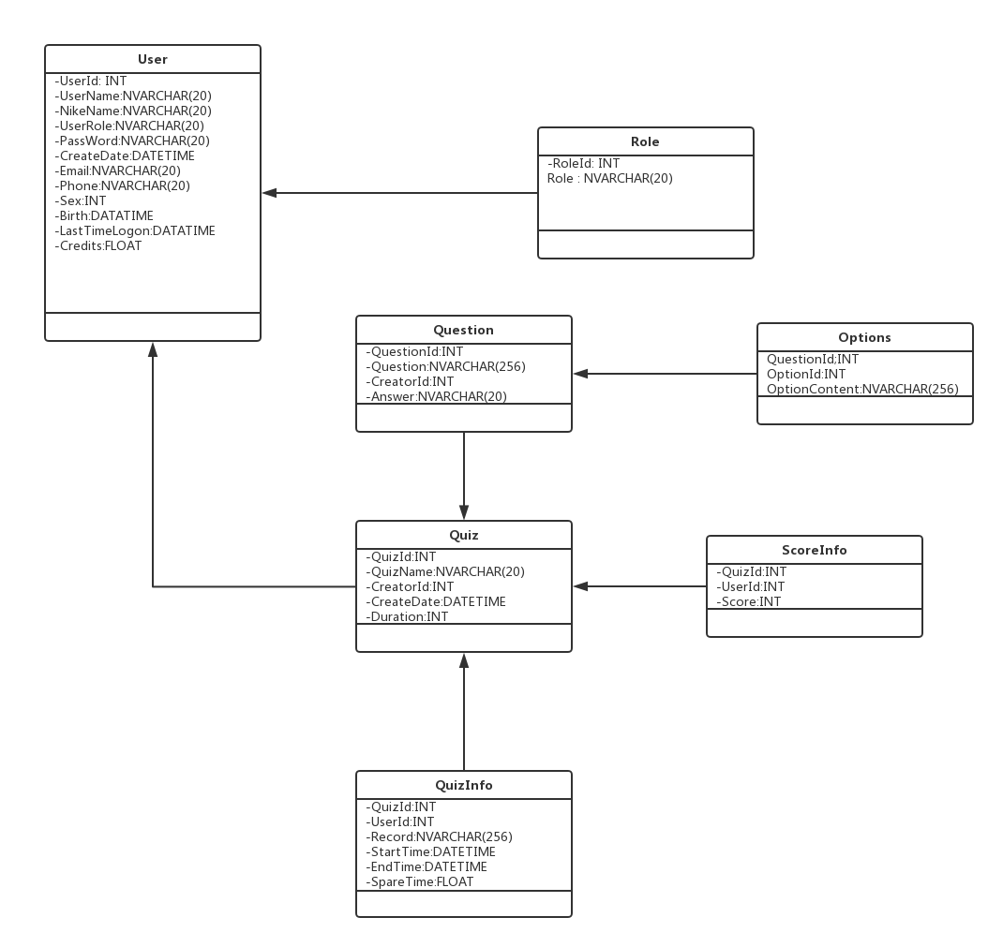

# Front-end

## Design module

MVC API design module is used in this project. The front-end will communicate with the database by Jason, which can get the info form database by decrypt Jason string. This can benefit the multi-platform development.

## Design pattern

Singleton: Allocate memory space for the class when App start running to increase the speed, rather than Allocate memory space when the specific class will be used to save the space. As the software is strong enough, and user is more careful about the user experience.

## Factory Method

Factory Method is a popular design pattern for further updating and iterating